Table of Contents
PhonePe Pulse Data Analysis Dashboard 1
📌 Project Overview: 1
Key Objectives: 2
The project demonstrates a complete data analytics pipeline, including: 2
🛠 Code and Resources Used : 2
Libraries Used: 2
Development Tools: 2
External Resources Used: 3
📊 Dataset Description: 3
Aggregated Data: 3
Map Data: 4
Top Data: 4
🧹 Data Cleaning and Preprocessing: 4
Data Cleaning Steps: 5
🔍 Exploratory Data Analysis (EDA): 5
Transaction Analysis for Market Expansion: 5
User Engagement and Growth Strategy: 5
Insurance Engagement Analysis: 6
Transaction Analysis Across States and Districts: 6
User Registration Analysis: 6
📈 Dashboard Features: 7
📷 Dashboard Preview: 7
🚀 How to Run the Project: 7
📊 Key Insights: 8
🔮 Future Improvements: 8

PhonePe Pulse Data Analysis Dashboard

📌 Project Overview:
This project analyzes digital payment trends in India using the PhonePe Pulse dataset and presents insights through an interactive Streamlit dashboard.
The objective of this project is to understand how digital payments are growing across India and identify patterns in transactions, user engagement, and insurance adoption.

Key Objectives:
• Analyze transaction value and volume across Indian states and districts
• Understand user registration growth and app engagement
• Identify regions with high digital payment adoption
• Study insurance usage trends within the PhonePe ecosystem
• Build an interactive dashboard to visualize insights

The project demonstrates a complete data analytics pipeline, including:
1.Data extraction from GitHub
2.Data transformation using Python
3.Data storage using SQL
4.Data analysis using SQL queries
5.Data visualization using Streamlit and Python libraries

🛠 Code and Resources Used :

Libraries Used:
Library | Purpose
Pandas | Data manipulation and analysis
Streamlit | Interactive dashboard development
MySQL Connector | Connecting Python with MySQL database
Matplotlib | Creating charts and plots
Plotly | Interactive visualizations
JSON | Parsing raw dataset files

Development Tools:
• Python
• Jupyter Notebook
• MySQL Database
• Streamlit
• Git & GitHub

External Resources Used:
1.PhonePe Dataset:
Dataset Source: PhonePe Pulse GitHub Repository
https://github.com/PhonePe/pulse
This repository contains public data about digital payments in India.
2.India Choropleth Map (GeoJSON):
The India state map used in the dashboard was obtained from:
https://gist.githubusercontent.com/jbrobst/56c13bbbf9d97d187fea01ca62ea5112/raw/e388c4cae20aa53cb5090210a42ebb9b765c0a36/india_states.geojson
This GeoJSON file is used to create the interactive India map visualization in the Streamlit dashboard.

📊 Dataset Description:
The dataset used in this project comes from the PhonePe Pulse GitHub repository.
The data is organized in JSON format and contains information about digital transactions across India.
The dataset is categorized into three main sections.

Aggregated Data:
Aggregated data provides summarized metrics across different states.
Tables created:
Table Name | Description
aggregated_user | Contains registered users and app opens
aggregated_transaction | Contains transaction value and transaction count
aggregated_insurance | Contains insurance transaction data

This data helps analyze:
• Transaction growth
• User adoption
• Insurance usage

Map Data:
Map data provides more granular location-based insights.
Tables created:
Table Name | Description
map_user | User distribution across districts
map_transaction | Transaction mapping across states and districts
map_insurance | Insurance distribution data

This data is useful for geographical analysis.

Top Data:
Top data provides the highest performing regions.
Tables created:
Table Name | Description
top_user | Top users by region
top_transaction | Top states, districts and pincodes by transaction
top_insurance | Top regions by insurance usage

This helps identify high-performing regions.

🧹 Data Cleaning and Preprocessing:
Before analysis, the dataset required several preprocessing steps.

Data Cleaning Steps:
• Extracted data from JSON files
• Converted nested JSON structures into structured tables
• Standardized state names for consistency
• Removed formatting issues such as hyphens in state names
• Converted data types for numerical analysis
• Handled missing values where necessary

🔍 Exploratory Data Analysis (EDA):
Exploratory Data Analysis was performed using SQL queries and Python visualizations.
The analysis focuses on five business case studies.

Transaction Analysis for Market Expansion:
This analysis explores:
• Total transaction value by state
• Total transaction count by state
• Year-wise transaction growth
• Quarterly transaction trends
• Average transaction value per state
Purpose:
To identify regions with strong digital payment adoption.

User Engagement and Growth Strategy:
Key metrics analyzed:
• Total registered users by state
• Total app opens by state
• User engagement rate
• Year-wise user growth
• Quarterly user growth trends
Purpose:
To understand user activity and engagement patterns.

Insurance Engagement Analysis:
Analysis includes:
• Insurance amount by state
• Total insurance policies by state
• District contribution to insurance value
• Year-wise insurance growth
• Average insurance value per district
Purpose:
To identify insurance adoption trends.

Transaction Analysis Across States and Districts:
This analysis explores:
• Top districts by transaction value
• Top pincodes by transaction count
• Average transaction value by district
• Transaction growth over time
Purpose:
To identify high-value digital payment regions.

User Registration Analysis:
Metrics analyzed:
• State-wise total registrations
• Quarterly registration growth
• Top districts by registration
• Top pincodes by registrations
Purpose:
To understand regional adoption of PhonePe services.

📈 Dashboard Features:
An interactive dashboard was built using Streamlit.
Main features include:
India Overview Map
The dashboard displays an interactive map showing:
• Transaction Value
• Registered Users
• Insurance Amount
Users can switch between different metrics using a dropdown.
Business Case Analysis
The dashboard contains five analytical sections.
Each section includes:
• SQL-based data queries
• Visualizations using Matplotlib and Plotly
• Key insights explaining the results
Interactive Filters
Users can interact with the dashboard by selecting:
• Year
• State
• Case study
This allows deeper exploration of the dataset.

📷 Dashboard Preview:

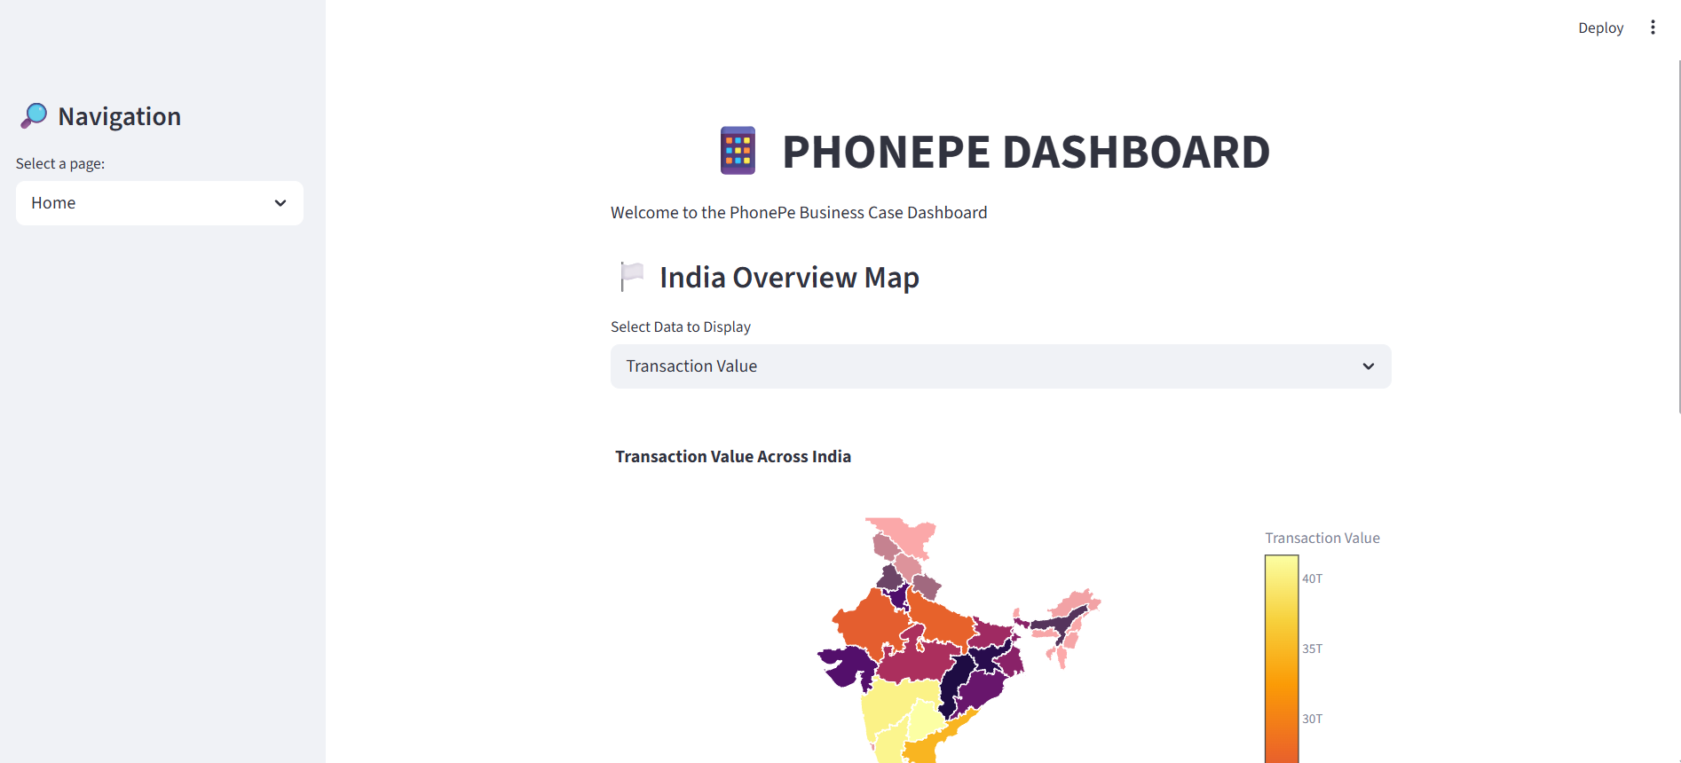

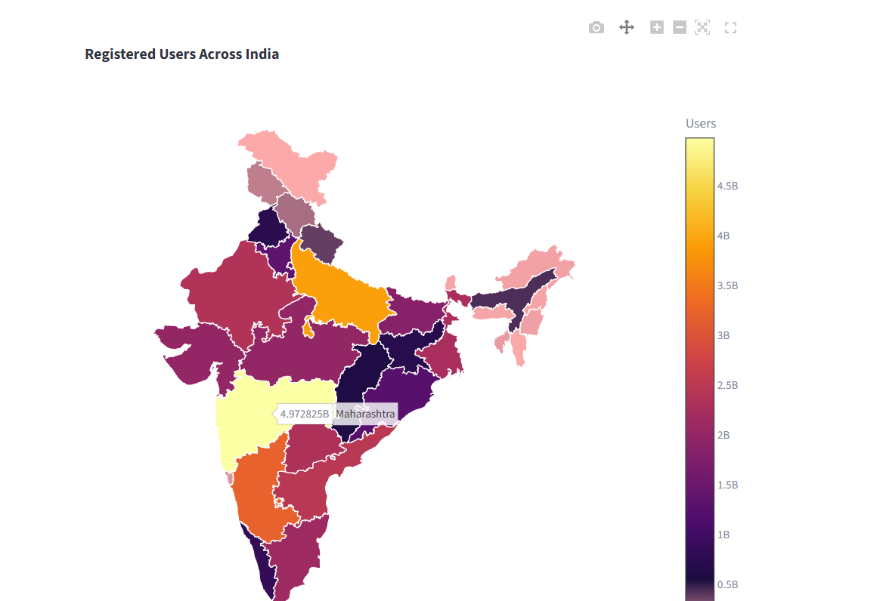

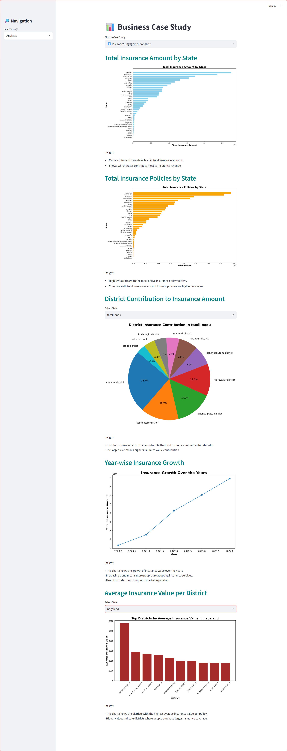

🚀 How to Run the Project:

Step 1:
Clone the repository
git clone https://github.com/yourusername/phonepe-pulse-dashboard.git

Step 2:
Install required libraries
pip install -r requirements.txt
Step 3:
Run the Streamlit application
streamlit run app.py

📊 Key Insights:
Some insights discovered during the analysis:
• Digital payment transactions have grown significantly over the years.
• States like Maharashtra and Karnataka dominate transaction value.
• High user registrations strongly correlate with high app engagement.
• Insurance adoption is increasing steadily across districts.
• Certain districts contribute disproportionately to transaction volume.

🔮 Future Improvements:
Possible enhancements for this project include:
• Adding district-level interactive maps
• Implementing real-time data updates
• Adding predictive analytics models
• Creating mobile-friendly dashboard layout
• Deploying the dashboard on Streamlit Cloud or AWS.

